Ex.No:1a | SETTING UP PYTHON ENVIRONMENT AND LIBRARIES – JUPYTER NOTEBOOK

AIM:
To install Python, configure Jupyter Notebook, understand the notebook environment,
execute Python programs, create Markdown cells, and use basic Jupyter Notebook features for Data Analytics applications

ALGORITHM:
- Start the program.
- Import the required libraries (if needed).
- Declare and initialize the required variables or data.
- Perform the required operations or processing.
- Display the output/results.
- Stop the program.

PROGRAM:
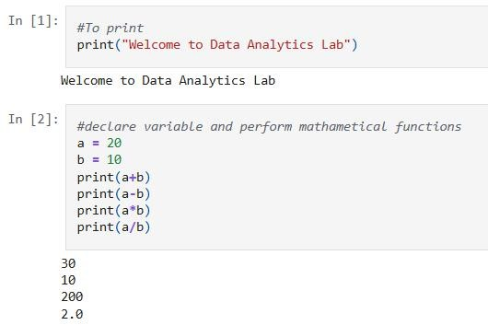

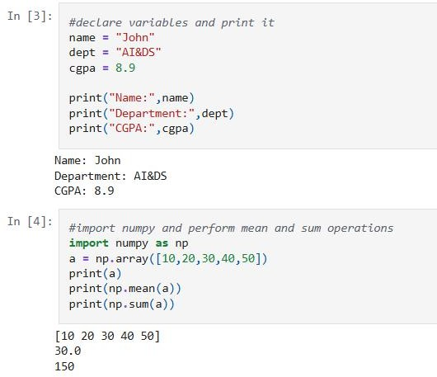
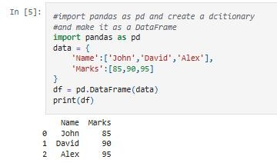

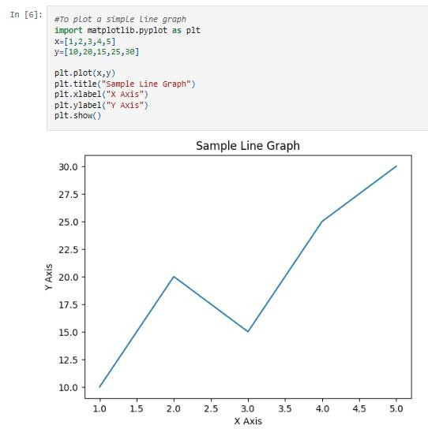

RESULT:
The program to perform basic mathematical operations is completed successfully.

